PLANIT GLOBAL

3D Avatar creator

Detailed documentation of the PLANitGLOBAL

3D avatar creator, powered by unity

**By: Sasha Grenier, Eric Preisig and Roel Meijns**

Detailed technical and functional documentation, Art Assets, Methodology

Index

1.0 Abstract 3

2.0 Current goal 4

4.0 Onboarding 5

5.0 Autonomy 5

6.0 System demands 6

6.1 Trust 6

6.2 User friendly 6

7.0 Technical design 6

7.1 Assumptions 6

7.2 Database (ERD) 7

7.3 Flowchart 8

7.4 Engine 9

# 1.0 Abstract

This report will define and elaborate on all the technical, functional and design aspects of the PLANit GLOBAL 3d avatar creator. “3d avatar” is the terminology used in this document, in which users can make their own avatar in 3d.

This report is aimed at informing those who want to understand the methodology of the 3d avatar creator, and collaborate or contribute towards its completion.

Copyright © PLANit GLOBAL

# 

# 2.0 Current goal

The main goal of the 3d avatar creator is to show yourself and the company better on the site. We are thinking that you can show yourself better with a 3D avatar. Also we want the 3D avatar done before the deadline beginning of October. So we can show it at the presentation.   
  
3.0 Requirements  
  
  
The 3d avatar creator and its requirements have to be considered essential for its creation. None of the requirements are optional or wishes, since the following listings will work together to form an environment that is specifically build for a certain user experience.  
  
Yuri will make the 3d animations for the avatar. With all the clothes, hair styles, faces etcetera. We(Sasha, Eric and Roel) can start with the UI and programming.

There will be no need of a new database. The assets of the 3d animation will be put in strings that’s why there’s no need for database changes.  
  
Core functionality

* Logging in with the business account he got from his boss.
* Access to the business profile page with logging in, business mode.
* Allow the user to remember the login credentials (This saves the user from having to type the login every time he want to enter the site.
* Click Menu Options( This opens the avatar creator tab.)
* Avatar Creator
* At first you choose between male or female.
* Now you can create your avatar like you want.
* Save (This saves your avatar after creating one.)
* Your boss needs to accept the creation of your avatar.

4.0 Onboarding  
  
  
The 3d avatar creator will not have an extensive tutorial. It speaks for itself. Its works exactly like the old avatar creator only with more functions and the 3d.

5.0 Autonomy  
  
  
The user is free to do whatever he/she want to do with the avatar. Only thing is that the boss needs to accept it. So because of this people will use it seriously.  
  
6.0 Persona

Example user persona  
  
Jack Williams is a 18 year old student from Wolverhampton. He is looking for some working experience. At school they told the students about a website called Planit. Jack creates an account and goes into his space ship in search of a good company. After he finds his section he flies into it and clicks on an interesting company. The building and avatar of the company goes on screen. The avatar have some questions and answers about the company.   
  
Example company persona  
  
After an company bought a business license of planIT it can acces the business page. At this page the company can add company information and create an avatar. This avatar represents the company. The questions and answers about the company will be told by the avatar. So the avatar is a very important part on the site.

Example Employee persona  
  
The employee works almost the same as the boss one. They also get a business account from their boss. The only thing different is that the employee avatar needs to be accepted by the boss.

7.0 System demands

## 7.1 Trust

PLANit GLOBAL want the avatar creator to play a bigger role on the site. You can represent yourself and your company with it. This means that the avatar creator needs to robust and smooth for operation.

## 7.2 User friendly

The users on the website can be come from any background and orientation, this means that the website needs to be streamlined enough in order to appeal to all users that visit the website. Some of the users might not be as patient with loading times while others have no problem with waiting.

If the system is not convenient enough for all the different the types of visitors on the website, the website will not be able to achieve its desired goal.

# 

# 8.0 Technical design

## 8.1 Assumptions

These are all the technical assumptions that are relevant for some of the questions surrounding the realization of some of the components.

* The boss of the company needs to accepts the changes.

* An user can change the avatar to whatever he want.

## 8.2 Database (ERD)

[Not Included]

8.3 Flowchart

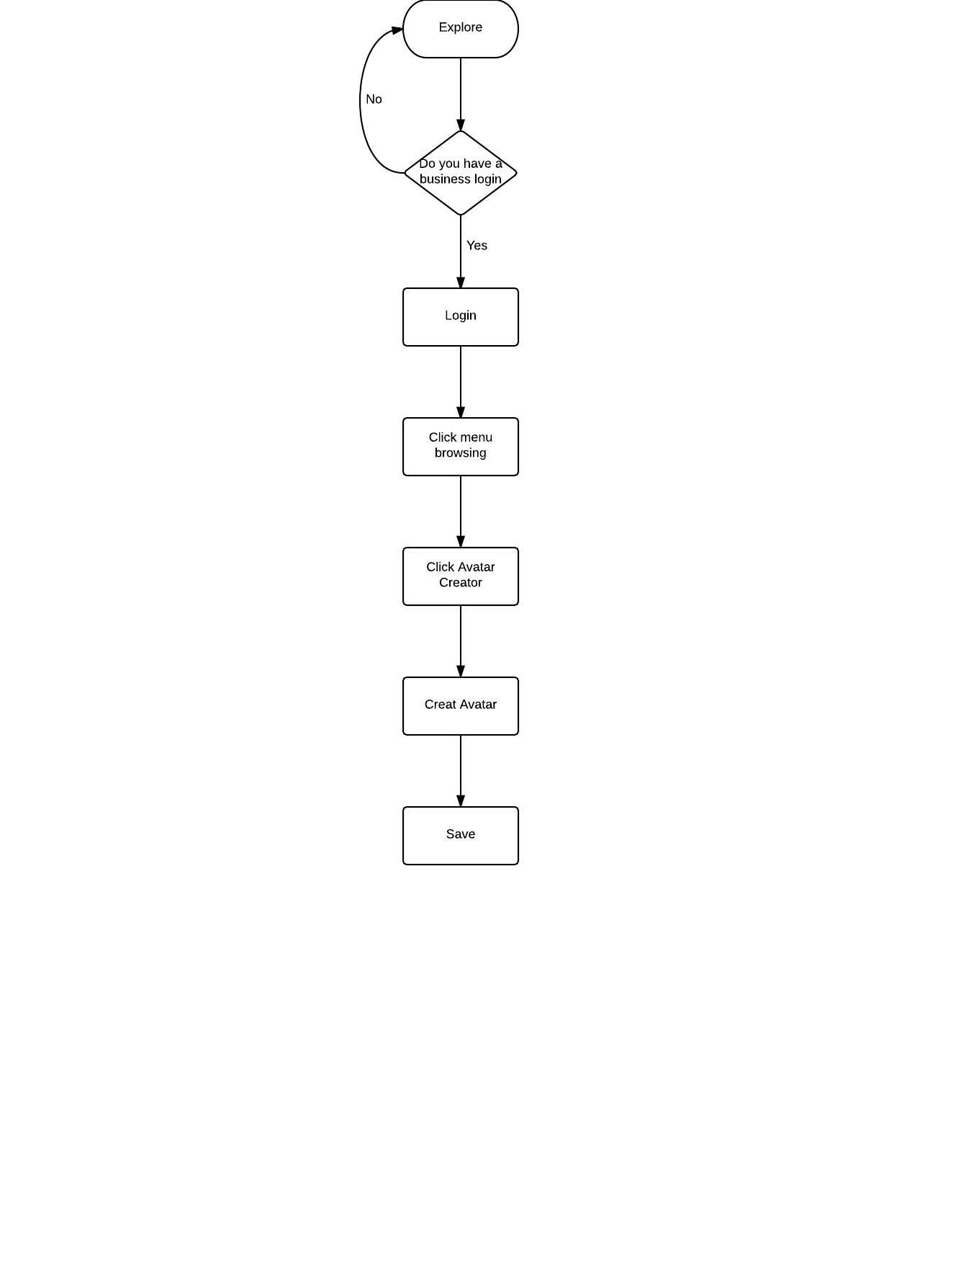

## 8.4 Engine

The engine that will be used is Unity 5.0. This will allow PLANit GLOBAL to have a 3d avatar creator.

# 9.0 General layout mockups

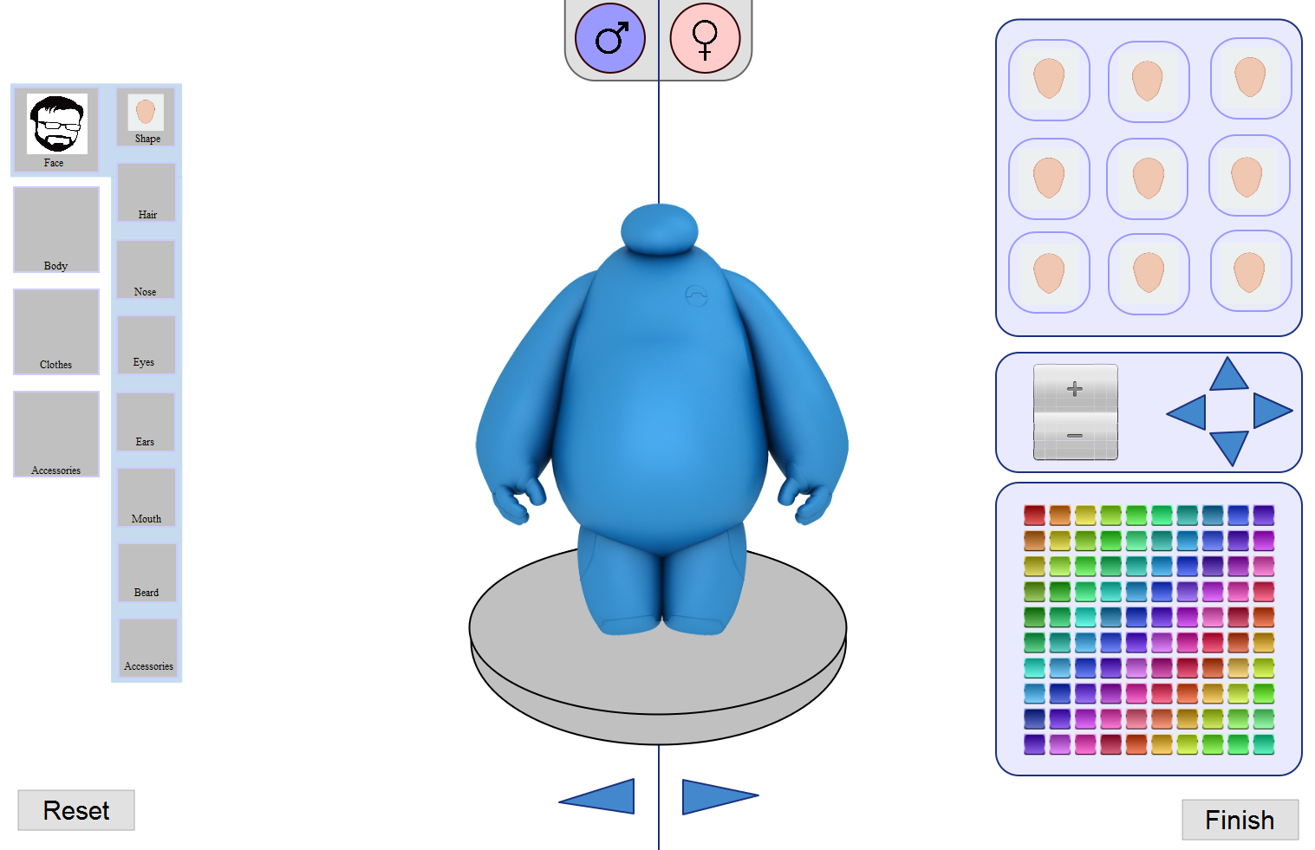  
  
This design is made in a program called Pencil. It’s a simple design of how we want it to look. The design of this mock-up is not our final product. We want it more to look like the 2d one (picture below). We added some changes to the old one because we needed to fit the whole 3d avatar in one screen.

